**Assignment No. 02**

**Encryption and Decryption Using Transposition Ciphers**

**Objective:**

* To understand and implement encryption and decryption using the Rail Fence cipher.
* To understand and implement encryption and decryption using the Row and Column Transposition cipher.

**A: Rail Fence Cipher**

**Theory:**

The Rail Fence cipher is a form of transposition cipher that writes the plaintext in a zigzag pattern across multiple "rails" and then reads off each row to create the ciphertext.

Example with 3 rails:

Plaintext: **HELLO WORLD**

Write in rails:

H L O L

E L W R D

L O _

Read row-wise: **HLOLELWRDLO**

**Steps:**

**Encryption:**

1. Choose the number of rails (key).
2. Write the plaintext in a zigzag pattern on rails.
3. Read the character’s row-wise to get ciphertext.

**Decryption:**

1. Write the ciphertext row-wise in rails.
2. Reconstruct the zigzag pattern to retrieve original plaintext.
3. import java.util.Scanner;
4. public class RailFenceCipher {
5. public static String encrypt(String text, int key) {
6. StringBuilder[] rails = new StringBuilder[key];
7. for (int i = 0; i < key; i++) rails[i] = new StringBuilder();
8. int dir = 1, row = 0;
9. for (char c : text.toCharArray()) {
10. rails[row].append(c);
11. row += dir;
12. if (row == key - 1) dir = -1;
13. else if (row == 0) dir = 1;
14. }
15. StringBuilder result = new StringBuilder();
16. for (StringBuilder rail : rails) result.append(rail);
17. return result.toString();
18. }
19. public static String decrypt(String cipher, int key) {
20. int[] railLengths = new int[key];
21. int row = 0, dir = 1;
22. for (int i = 0; i < cipher.length(); i++) {
23. railLengths[row]++;
24. row += dir;
25. if (row == key - 1) dir = -1;
26. else if (row == 0) dir = 1;
27. }
28. String[] rails = new String[key];
29. int start = 0;
30. for (int i = 0; i < key; i++) {
31. rails[i] = cipher.substring(start, start + railLengths[i]);
32. start += railLengths[i];
33. }
34. int[] railIndices = new int[key];
35. StringBuilder result = new StringBuilder();
36. row = 0; dir = 1;
37. for (int i = 0; i < cipher.length(); i++) {
38. result.append(rails[row].charAt(railIndices[row]++));
39. row += dir;
40. if (row == key - 1) dir = -1;
41. else if (row == 0) dir = 1;
42. }
43. return result.toString();
44. }
45. public static void main(String[] args) {
46. Scanner sc = new Scanner(System.in);
47. System.out.print("Enter text: ");
48. String text = sc.nextLine().replaceAll("\\s+", "").toUpperCase();
49. System.out.print("Enter key (number of rails): ");
50. int key = sc.nextInt();
51. String encrypted = encrypt(text, key);
52. System.out.println("Encrypted: " + encrypted);
53. String decrypted = decrypt(encrypted, key);
54. System.out.println("Decrypted: " + decrypted);
55. sc.close();
56. }
57. }

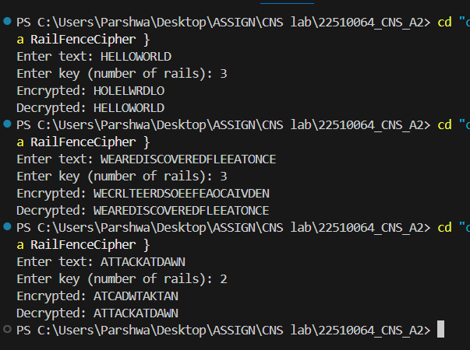

**Observation:**

**1-The zigzag pattern distributes characters across 3 rails, and reading row-by-row shuffles them. Decryption perfectly restores original text.**

**2-The Rail Fence works well with longer text; the distribution is more uniform across rails. No padding is required since length fits naturally.**

**3-With 2 rails, the pattern is simpler (alternating characters). Useful for faster manual encryption but easier to break.**

**General Analysis for Rail Fence:**

**Works by rearranging order of characters without changing them.**

**Security depends on the number of rails (small keys are easier to crack).**

**Easy to implement and decrypt when key is known.**

**Not suitable for strong security in modern use.**

**B: Row and Column Transposition Cipher**

**Theory:**

The Row and Column transposition cipher arranges the plaintext into a matrix and then permutes the columns based on a key to get ciphertext.

**Steps:**

**Encryption:**

1. Write the plaintext in rows of a matrix (number of columns depends on key length).
2. Rearrange columns according to the alphabetical order of the key.
3. Read the matrix column-wise to get ciphertext.

**Decryption:**

1. Write ciphertext column-wise based on the key order.
2. Rearrange columns back to the original key order.
3. Read rows to get plaintext.

**Example:**

* Key: **ZEBRA** (Assign numerical order based on alphabetical: A=1, B=2, E=3, R=4, Z=5)
* Plaintext: **WE ARE DISCOVERED FLEE AT ONCE**

**Conclusion:**

* Rail Fence cipher uses zigzag pattern for transposition.
* Row and Column cipher rearranges characters in a matrix based on a key.
* Both ciphers provide a basic introduction to transposition techniques.

import java.util.*;

public class RowColumnTransposition {

    // Generate column read order based on the key sequence

    public static int[] getOrder(int[] key) {

        int[] order = new int[key.length];

        Integer[] idx = new Integer[key.length];

        for (int i = 0; i < key.length; i++) idx[i] = i;

        Arrays.sort(idx, Comparator.comparingInt(i -> key[i]));

        for (int i = 0; i < key.length; i++) {

            order[i] = idx[i];

        }

        return order;

    }

    public static String encrypt(String text, int[] key) {

        int cols = key.length;

        int rows = (int) Math.ceil((double) text.length() / cols);

        char[][] matrix = new char[rows][cols];

        int index = 0;

        // Fill row-wise

        for (int r = 0; r < rows; r++) {

            for (int c = 0; c < cols; c++) {

                matrix[r][c] = (index < text.length()) ? text.charAt(index++) : 'X';

            }

        }

        StringBuilder result = new StringBuilder();

        int[] order = getOrder(key);

        // Read columns in sorted key order

        for (int colIndex : order) {

            for (int r = 0; r < rows; r++) {

                result.append(matrix[r][colIndex]);

            }

        }

        return result.toString();

    }

    public static String decrypt(String cipher, int[] key) {

        int cols = key.length;

        int rows = (int) Math.ceil((double) cipher.length() / cols);

        char[][] matrix = new char[rows][cols];

        int index = 0;

        int[] order = getOrder(key);

        // Fill columns in sorted key order

        for (int colIndex : order) {

            for (int r = 0; r < rows; r++) {

                matrix[r][colIndex] = cipher.charAt(index++);

            }

        }

        StringBuilder result = new StringBuilder();

        // Read row-wise

        for (int r = 0; r < rows; r++) {

            for (int c = 0; c < cols; c++) {

                result.append(matrix[r][c]);

            }

        }

        return result.toString().replaceAll("X+$", "");

    }

    public static void main(String[] args) {

        Scanner sc = new Scanner(System.in);

        System.out.print("Enter text: ");

        String text = sc.nextLine().replaceAll("\\s+", "").toUpperCase();

        System.out.print("Enter key length: ");

        int keyLength = sc.nextInt();

        int[] key = new int[keyLength];

        System.out.println("Enter key sequence (1-based column order): ");

        for (int i = 0; i < keyLength; i++) {

            key[i] = sc.nextInt();

        }

        String encrypted = encrypt(text, key);

        System.out.println("Encrypted: " + encrypted);

        String decrypted = decrypt(encrypted, key);

        System.out.println("Decrypted: " + decrypted);

        sc.close();

    }

}

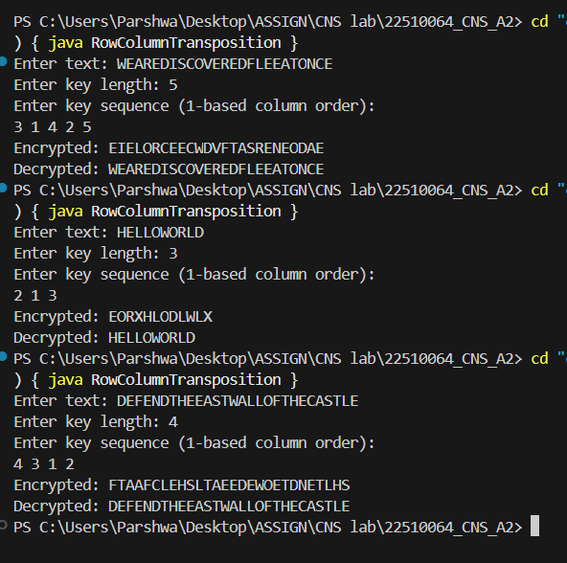

**1-Observation: Padding 'X' is added at the end to fill the last row. The key sequence changes column order, producing a more scrambled ciphertext.**

**2-Padding 'X' again ensures the final matrix is complete. Smaller keys lead to simpler permutations.**

**3-Column order drastically changes placement of letters, producing a ciphertext that is harder to guess without knowing the exact key order.**

**General Analysis for Row & Column:**

**Stronger than Rail Fence for the same text length because of key-based permutation.**

**Padding may be required to complete the matrix.**

**More resistant to simple frequency analysis but still vulnerable to known-plaintext attacks.**